Google Analytics Assignment

Name: Josva Rochi. R

Email :josva6438@gmail.com

**Introduction:**

This assignment provides a comprehensive, hands-on approach to understanding the setup and application of google analytics 4 (GA4) for web analytics. This assignment guides to creating a data stream, event as key event to track conversions. The second phase utilizes the google merchandise store demo account to explore and analyze real world website data. Key metrics such as user acquisition channels, event tracking, audience demographics, E-commerce performance, demonstrating practical use of GA4 reports and features.

First step as the assignment details says that to create an account so that I have created, Then I have created an new property named as an “Assignments property” and inside the property created an new data called “Assignment data stream”, From there I have created an custom event named as an “contact_pageveiw”. This is screenshot,

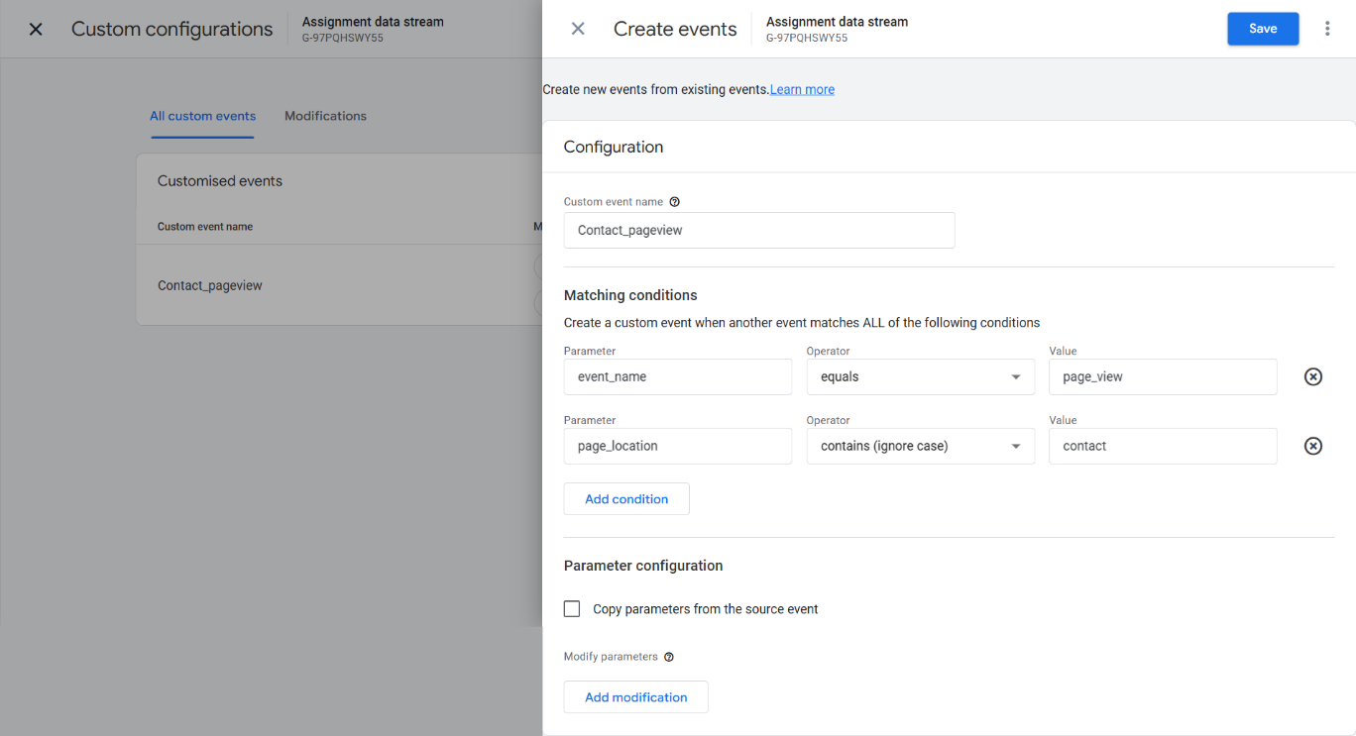

Then I got an acess on the google analytics GA4 property: google merchandise store(web data) by the given link:

<https://support.google.com/analytics/answer/6367342#access&zippy=%2Cin-this-article>

**traffic sources and campaign performance**

* How many users came from paid search in the first half on 2024?

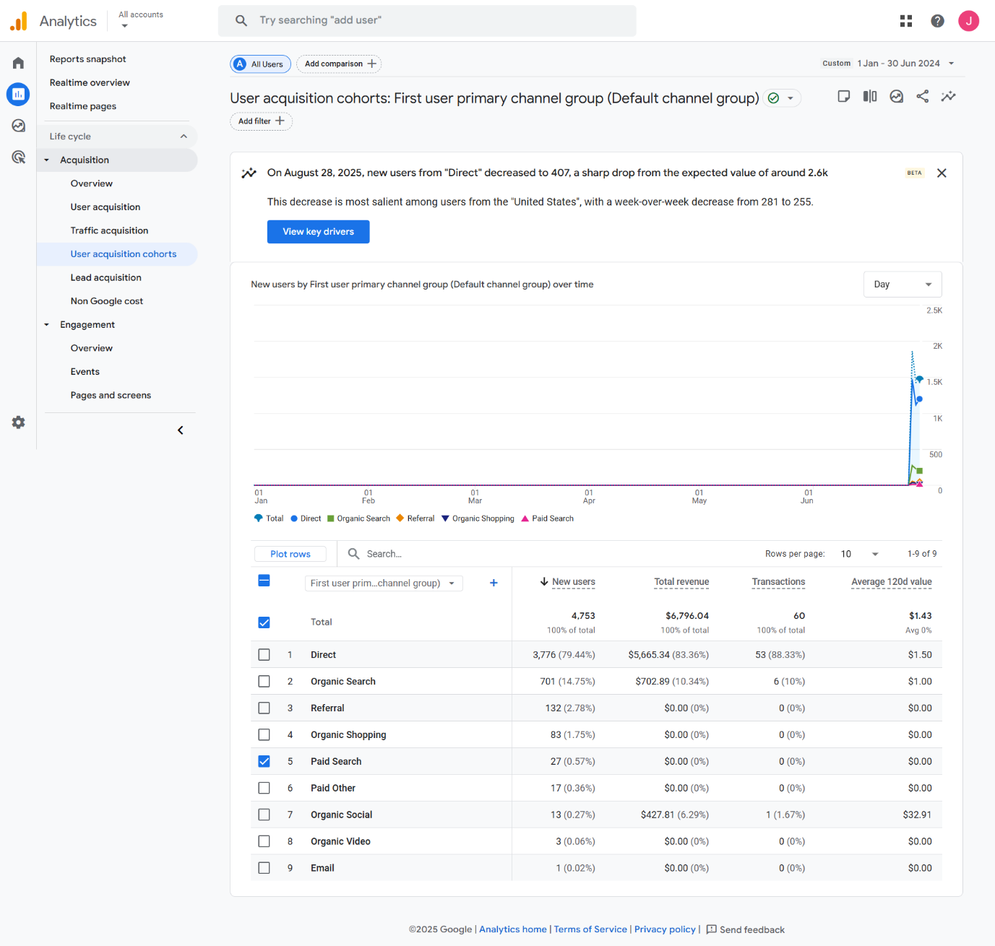

For an paid search users in the first half of 2024 is “27”(0.57%) in the total users of 4753.

How many session were generated from organic search in July 2024?

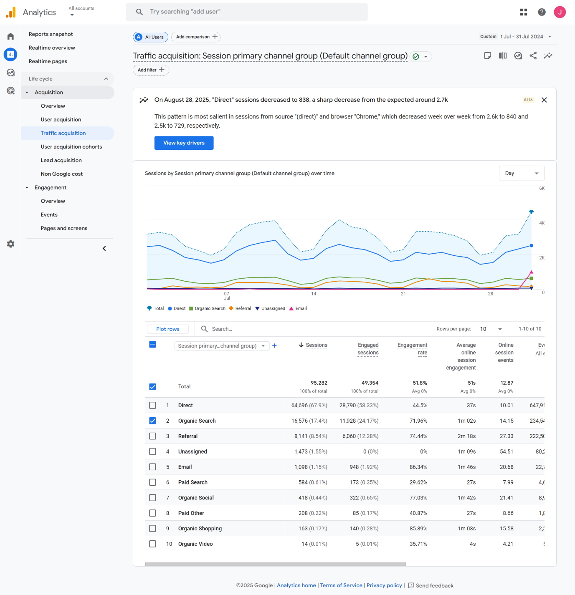

For an organic search session in July of 2024 is “16576”(17.4%) in the total sessions of 95282.

* what was the total revenue generated from the organic search in July 2024?

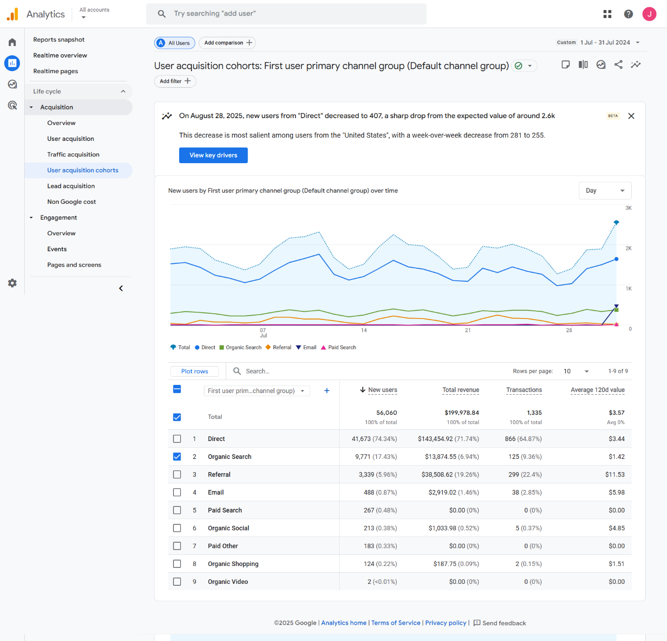

For an total revenue of organic search in July of 2024 is $199,978.84.

**Event tracking and custom dimensions**

* how many times did the “view promotion” event get recorded in January 2024?

No data was available for this.

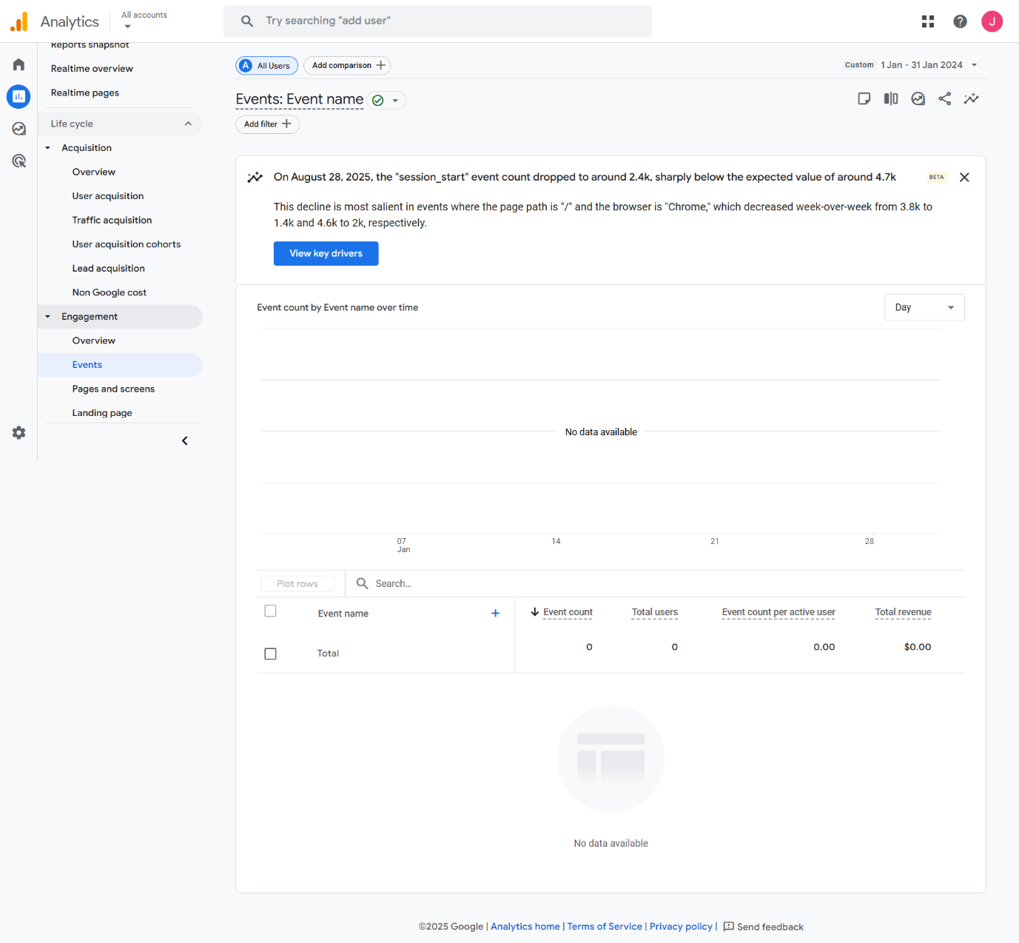

What was the most common event triggered by users in the month of march 2024?

No data was available for this.

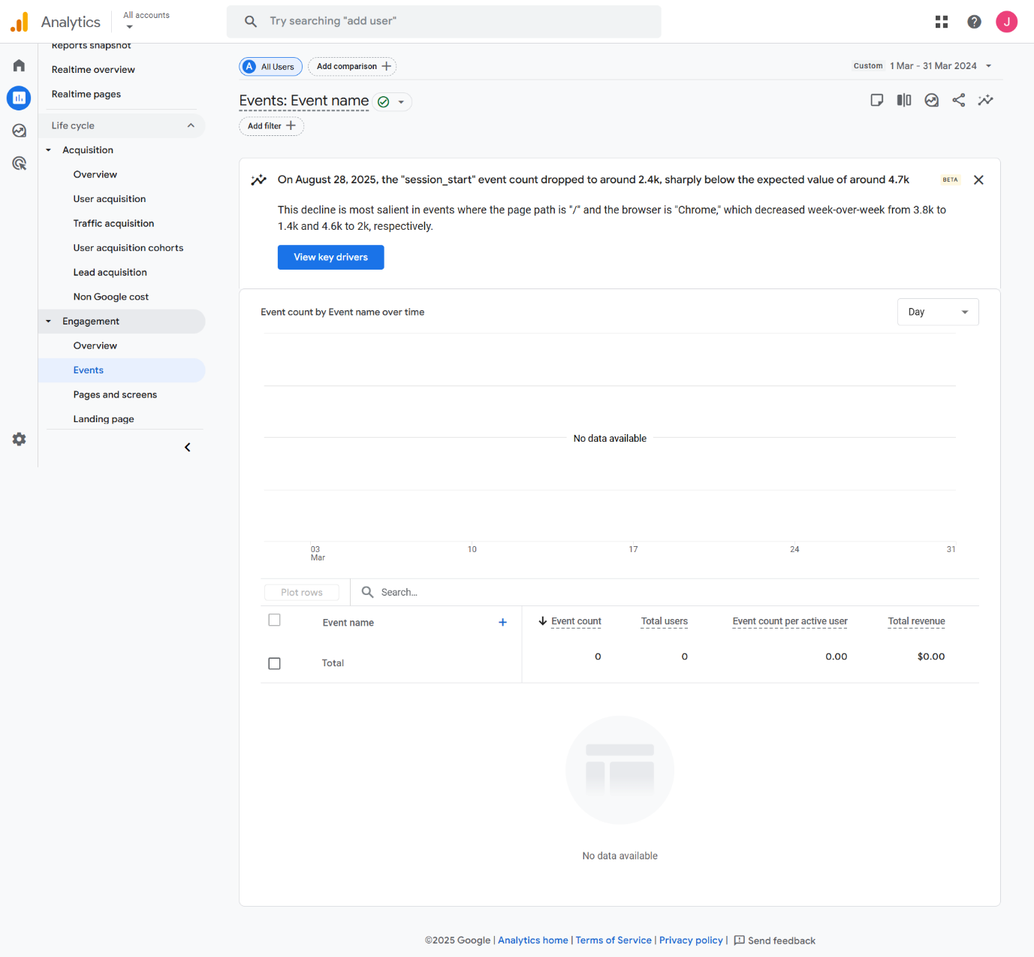

* how many users completed a “purchase” event in the second quarter of 2024?

1. users completed a purchase in the total of 250 in the second quarter.

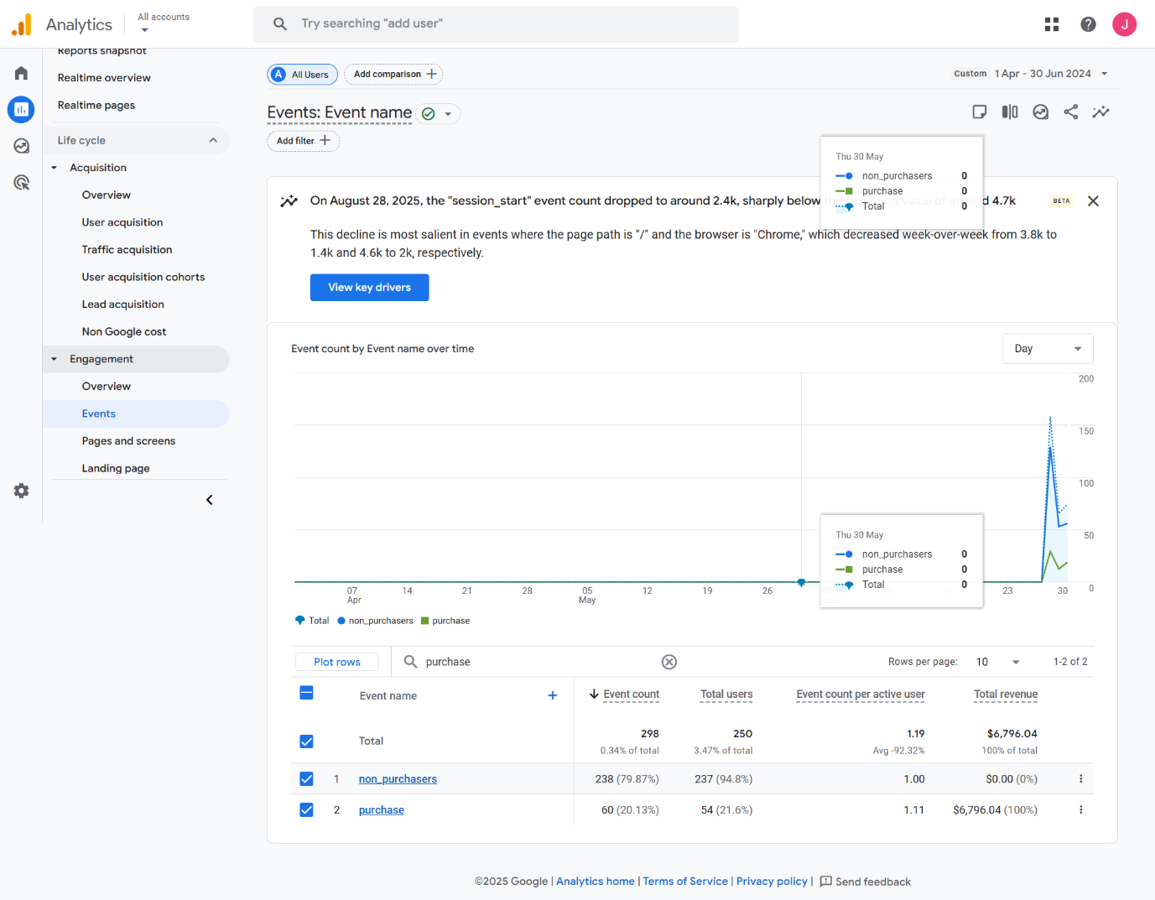

* How many users viewed the cart in the August 2024?

4001 users has viewed the cart in total of 5267.

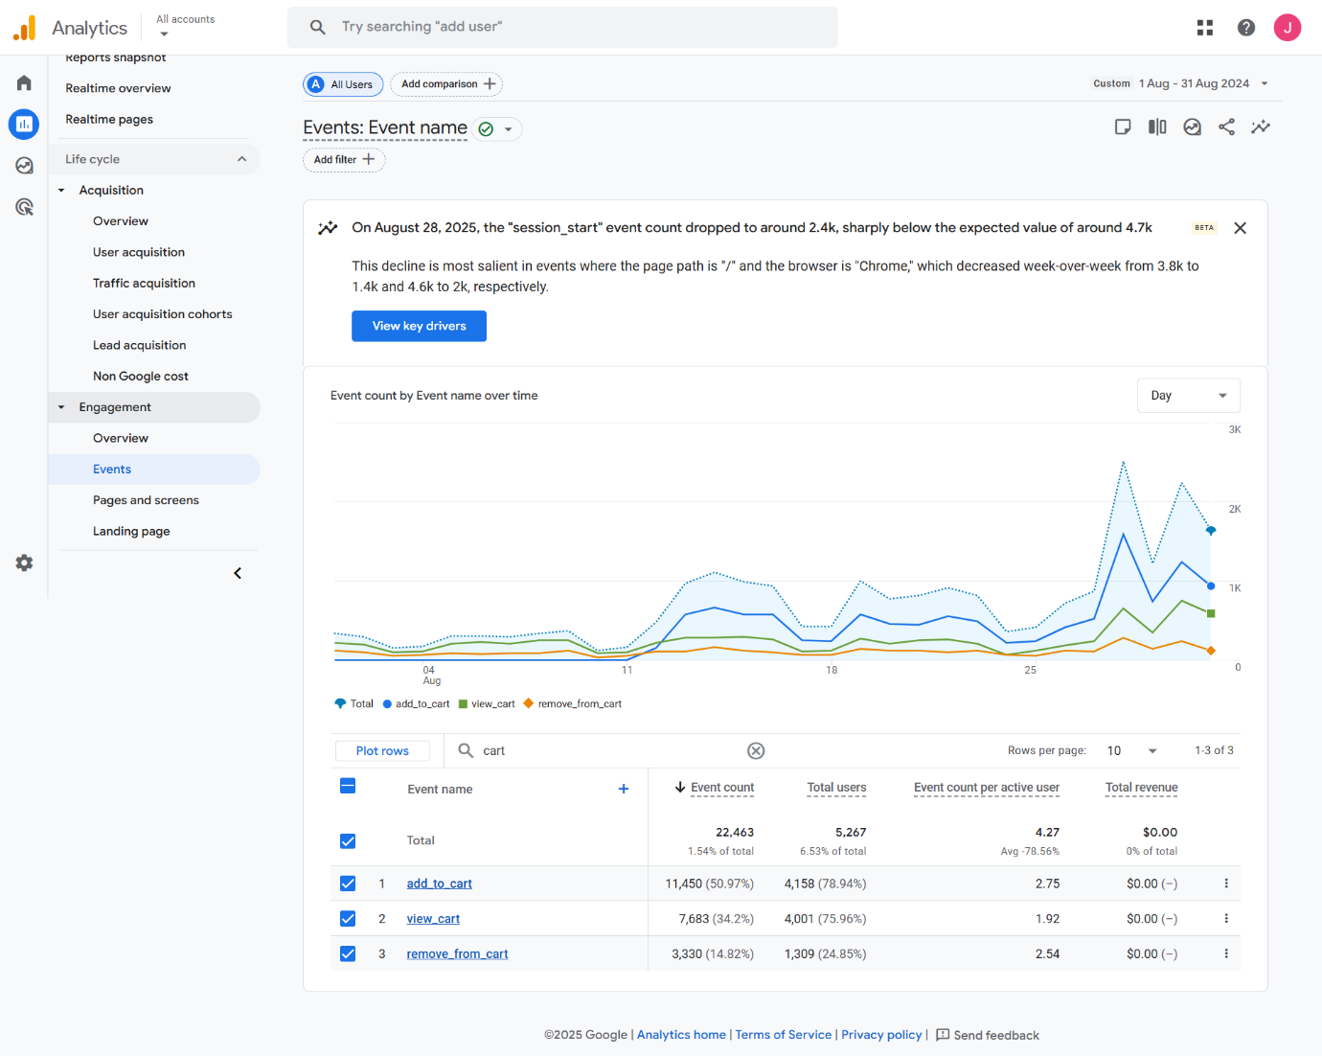

**Audience and demographics and interests**

* What percentage of users were aged between 25-34 in the third quarter of 2024?

14252 (7.33%) users were aged between 25-34 in Total users of 194,480

In the Third quarter of 2024.

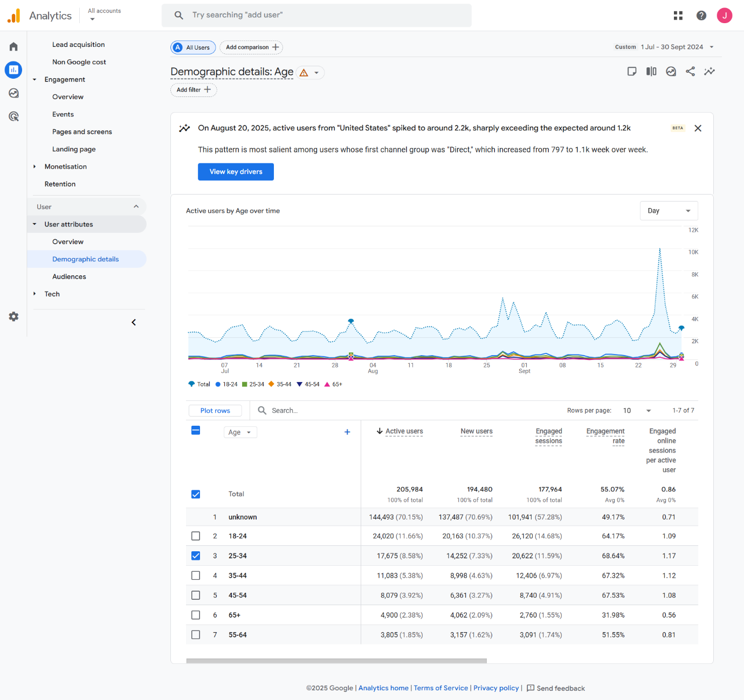

* Which city had the 2nd highest number of users in June 2024?

New york city has 2nd highest number of users in June 2024.

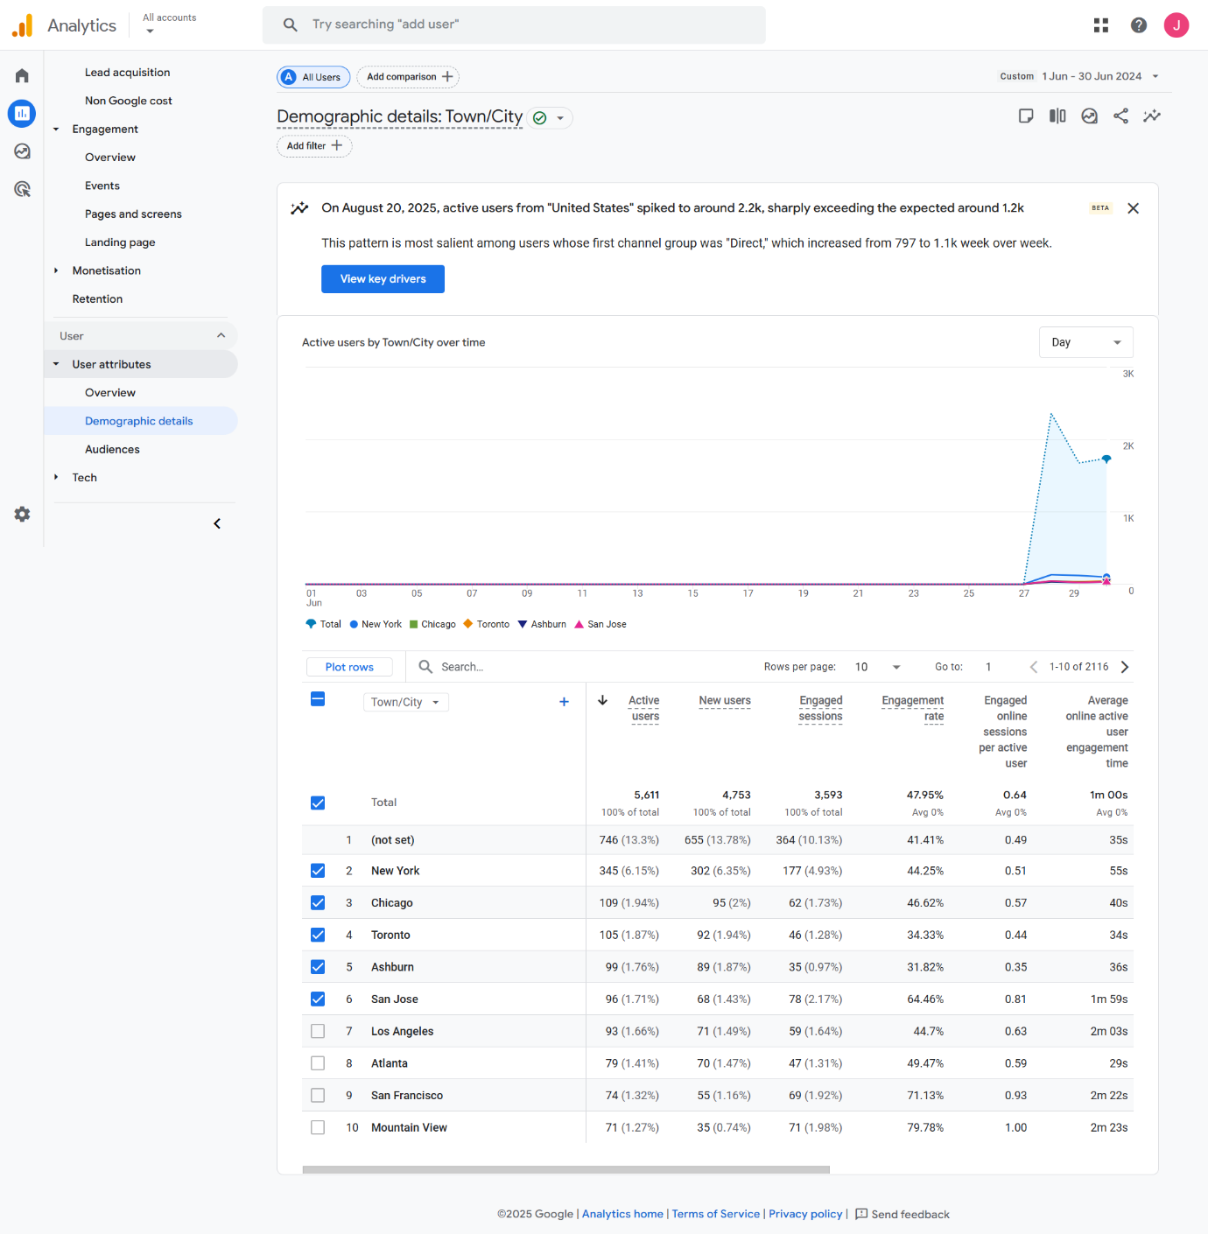

* What were the top three interests of users visiting the website in October 2024?

The top three interests in the October 2024 are:

* Technology/Technophiles
* Lifestyles & Hobbies/Shutterbug
* Banking& Finance/Avid investors

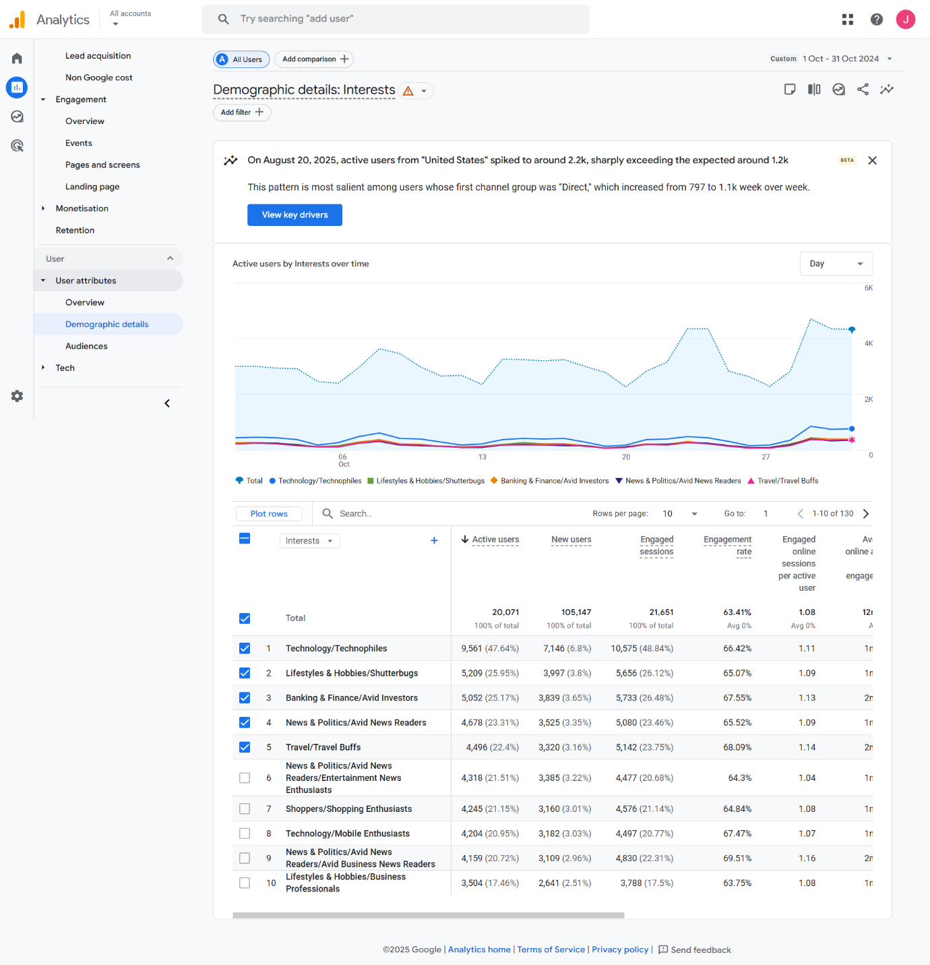

* How many users in the age group of 18-24 visited the websites in November 2024?

6612 users in the age group of 18-24 visited the websites in November in 2024 in total of 74924.

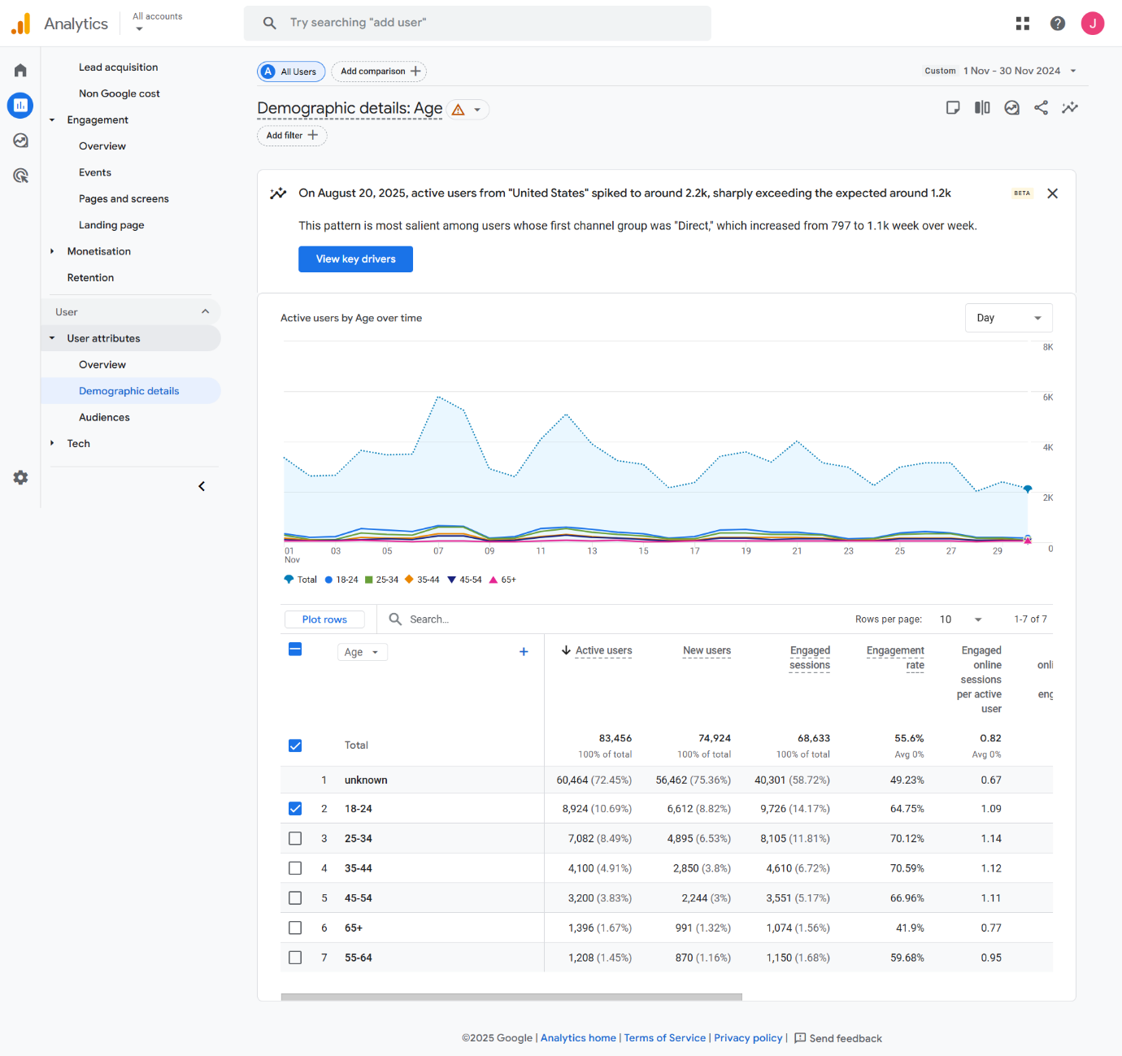

* What was the percentage increase in male users in the third quarter of 2024 compared to the second quarter ?

I have shown the image which shows an camparison of the both quarter.

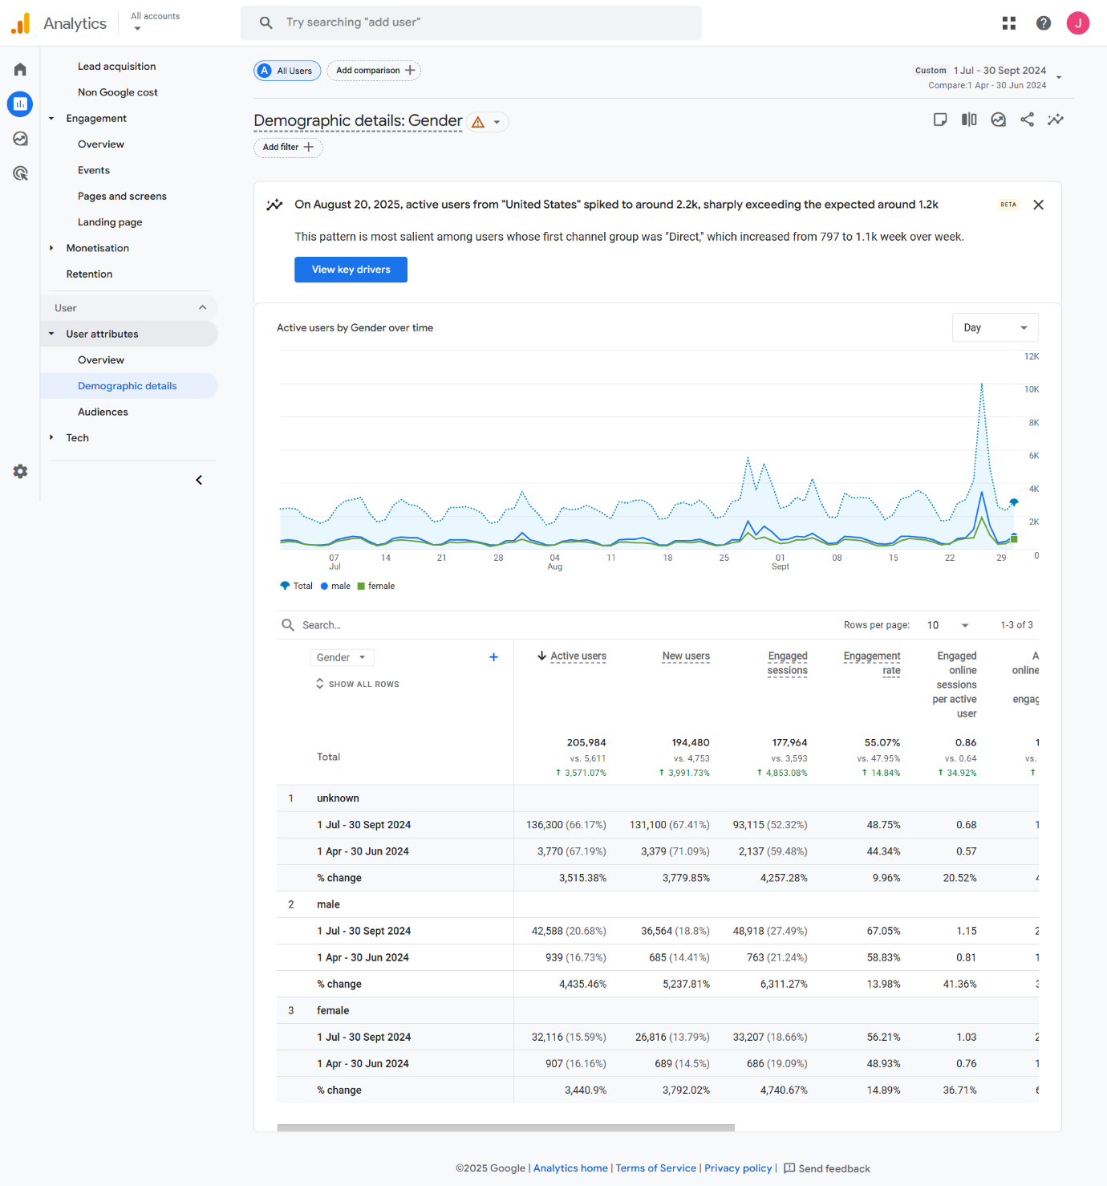

**E-commerce and conversion Analysis**

* What was the total revenue for transaction in February 2024?

The total revenue was an $0.

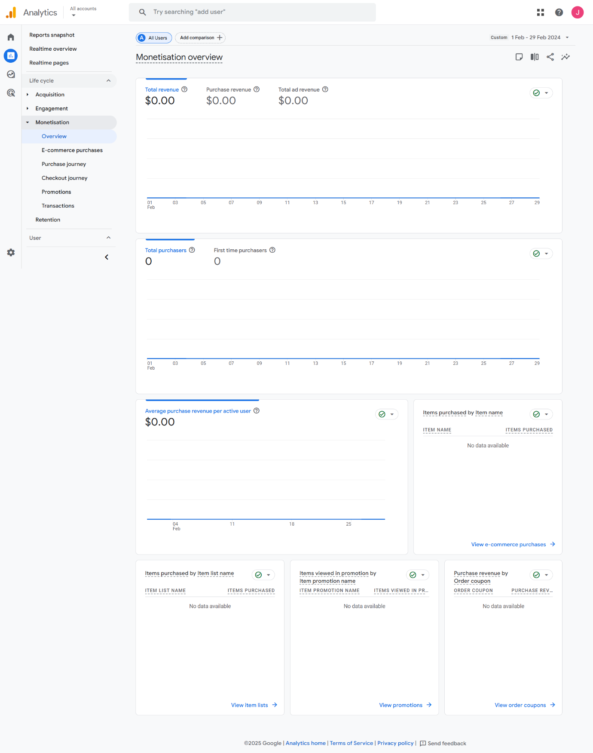

* Identify the item name with the highest sales in august 2024?

The highest sale item was google sensory support event kit.

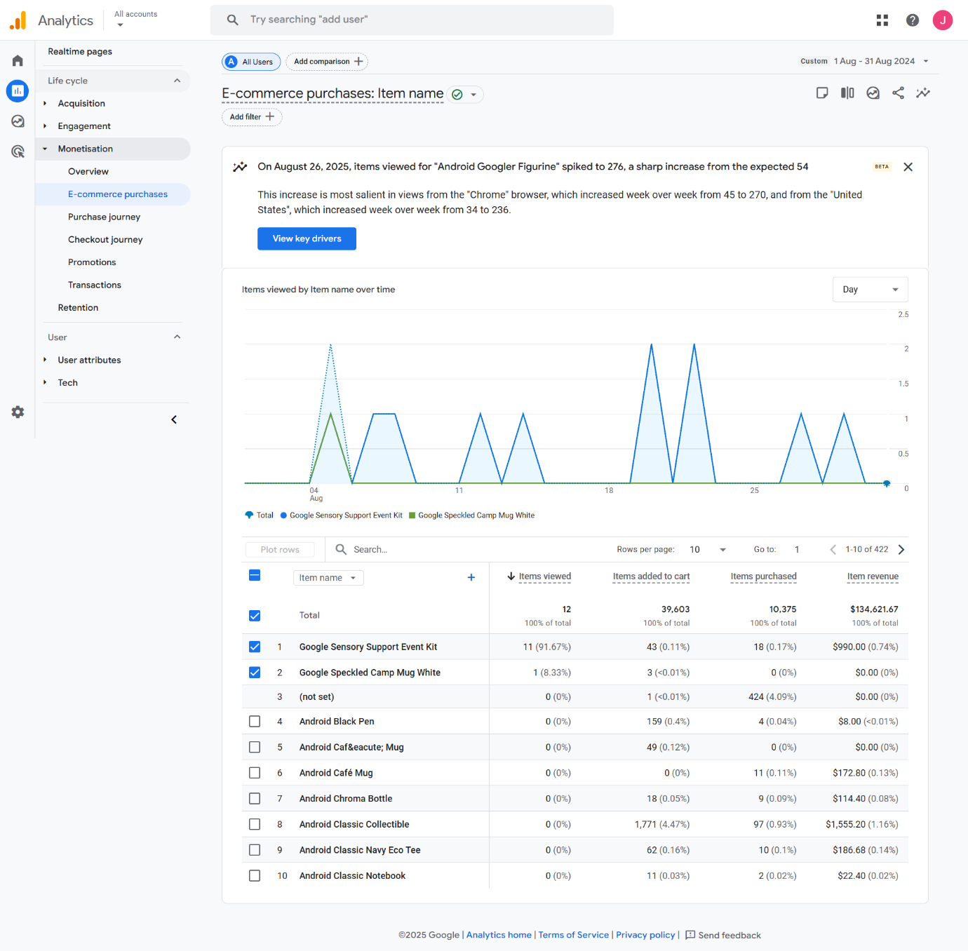

* How many abandoned shopping carts were there in September 2024?

The abandoned shopping carts are 48158 in the September 2024.

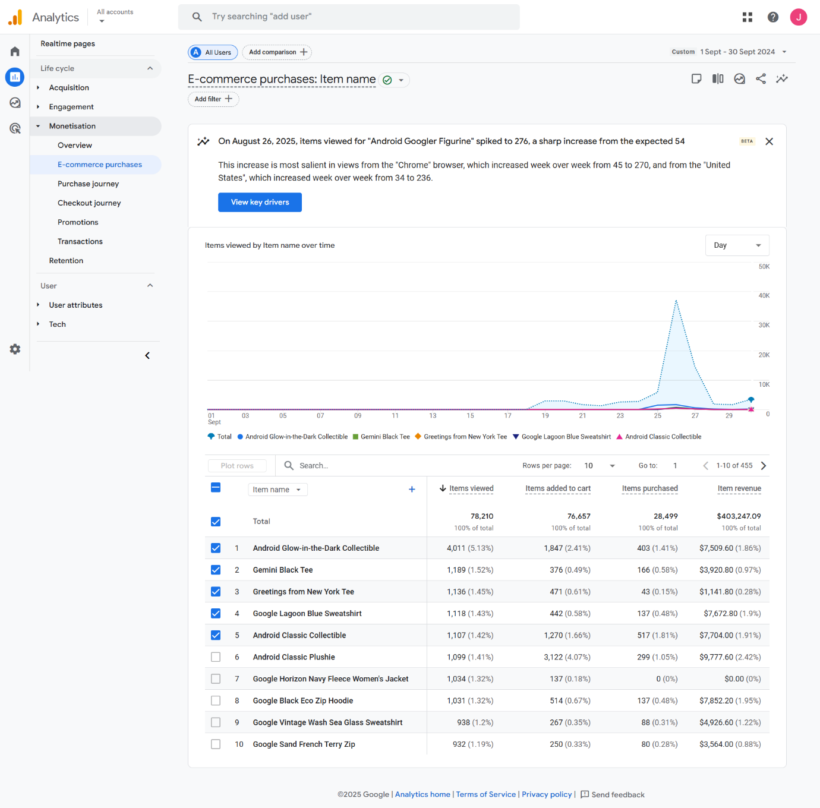

**Conclusion:**

By completing this assignment, practical experience was gained in both the technical configuration of google analytics.